Design a java code to implement method overloading

public class Overload

{

String test(int value)

{

return String.format("%d",value);

}

String test(double value)

{

return String.format("%.3f",value);

}

String test(String value)

{

return String.format("%.2f",Double.parseDouble(value));

}

public static void main(String[] args) {

Overload ob= new Overload();

System.out.println(ob.test(500));

System.out.println(ob.test(89.9934));

System.out.println(ob.test("550"));

}

}

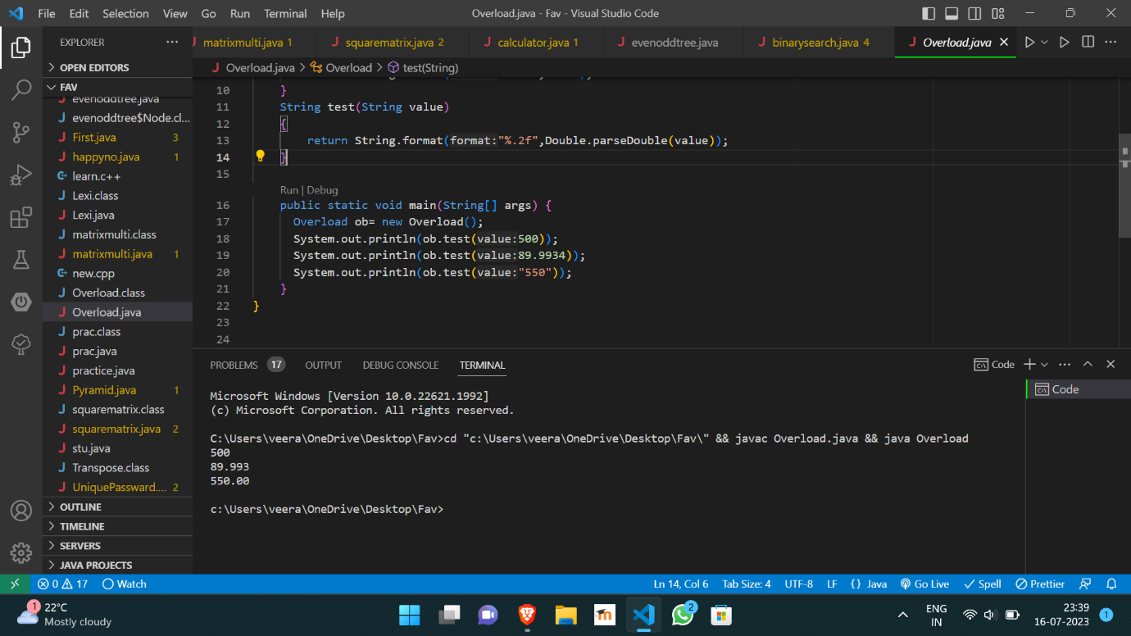

https://github.com/Veeragoutham04/Java_Lab/blob/main/Method%20overloading